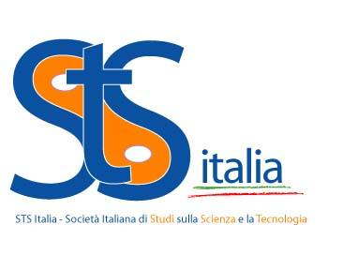

4nd STS Italia Summer School

“Almost Humans: Robotics, Healthcare and STS”
5th – 9th September, 2017 Catania, Italy

APPLICATION FORM

First Name: …………………………………………….

Family Name: ………………………………………….

Date of birth: ......................................................

Contact data:

Address : .........................................................................................................………………….

City: ……………………………………….. Country: ..................................................

ZIP-Code: ............................................... Tel.: .........................................................

E-mail: ..................................................... Fax: …………………………………….......

Current position and scientific curriculum:

...........................................................................……………..………………………………………

How do my PhD project and/or research interests relate to this Summer School? (MAX 500 WORDS)

……………………………………………………………………………………………………

Statement of purposes (mandatory only for scholarship applications – MAX 500 WORDS):

……………………………………………………………………………………………

